Basic Calculus | 3rd Quarter
Activity 3.6: Infinite Limits
February 4 2021
Page 18

- --
- --
- --
- --
- --
- --
- --
- --
- --

Proof analytically:
Limit Theory:

Proof graphically:

or

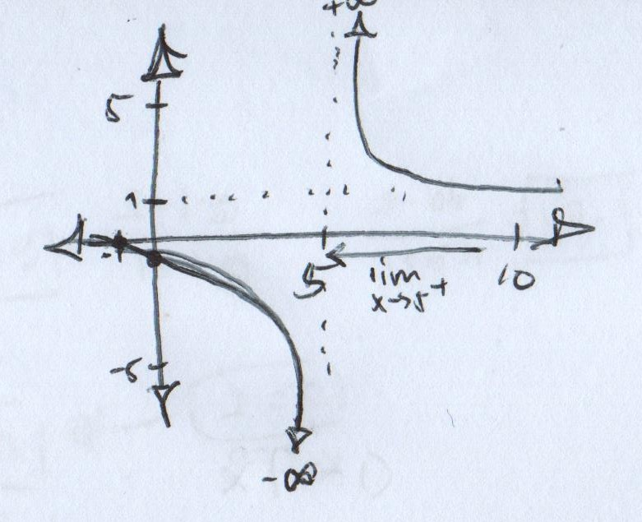
- --

Proof analytically:

Therefore, the graph, as it approaches -2 from the right hand side, must be going deeper and deeper.

Proof graphically:

|
|

